Paper Title in Arial 18-point, Bold and Centered

Author, Author*
Affiliation of the author(s) from the first institution
*corresponding.author@email.com

Author
Affiliation of the author(s) from the second institution
In Times New Roman 10 italic

ABSTRACT

The first section of the manuscript should be abstract, where the aims, scope, and conclusions of the papers are shortly outlined, normally between 200 and 300 words. Times New Roman-10 italic.

Keywords: Maximum 5 keywords; Separated by ;.

Title of First Section (Arial 11 Bold)

Leave one blank line between the heading and the first line of the text. No indent on the first para after the title; 10 mm indent for the subsequent para. At the end of the section, leave two blank lines before the next section heading.
The text should be right and left justified. The recommended font is Times New Roman, 10 points. In 152 mm x 227 mm paper size, the margins are: left and upper: 22 mm each; right: 20 mm, lower: 25 mm.

Secondary headings (Arial 10 Bold)
The text starts the immediately following line. Leave one blank line before each secondary heading.

Tertiary headings (Arial 10)
If they are required, the tertiary headings shall be underlined. Leave one blank line before tertiary headings. Please, do not use more than three levels of headings, try to keep a simple scheme.
Tables and illustrations should be numbered with Arabic numbers. Tables and illustrations should be centered with illustration numbers written one blank line, centered, after the relevant illustration. Table number is written one line, centered, before the relevant table. Leave one blank line before the table or illustration.
Authors should appreciate the importance of good-quality illustrations. Authors need to provide proof of publication consent to use figure(s) or table(s) from another publisher. All figures must be numbered consecutively with Arabic numerals. A detailed caption should be provided below each figure according to the following format:

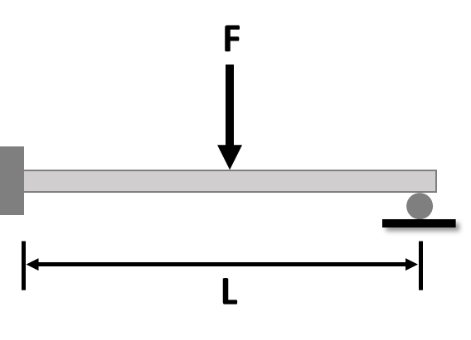
Figure 1: 2-D simply supported cantilever

For data plots, make sure to label all axes, specify units for quantities, label all curves and data sets, and use a legible font size. All graphs, diagrams, and tables should be referred to, for example, Figure 1 and Table 1 in the text.

Table 1: Minimum values of spacing and edge and end distances

Title 1 | Title 2 | Title 3
Label | Text / Numeric | Text / Numeric
Label | Text / Numeric | Text / Numeric
Label | Text / Numeric | Text / Numeric
Label | Text / Numeric | Text / Numeric
Label | Text / Numeric | Text / Numeric
Label | Text / Numeric | Text / Numeric
Label | Text / Numeric | Text / Numeric
Label | Text / Numeric | Text / Numeric

The International System of Units (SI) is to be used; other units can be used only after SI indications and should be added in parenthesis.
Equations should be typed and all symbols should be explained within the manuscript. An equation should be proceeded and followed by one blank line and should be referred to, in the text, in the form of Equation (1).

$$y=A+Bx+Cx^{2}$$ | (1)

Last point: the references. In the text, the references should be a number within square brackets, e.g. [3], or [4]–[6] or [2, 3]. The references should be listed in numerical order at the end of the paper. The number of references should be more than 20 with at least 40% of the references are less than 5 years, inclusive of at least 2 references from the current year.
Journal references should be according to IEEE format, which includes all the surnames of authors and their initials, year of publication in parenthesis, full paper title within quotes, a full or abbreviated title of the journal, volume number, issue number, and pages. Examples below show the format for references including books and proceedings.

Contributions of Authors

The authors confirm the equal contribution in each part of this work. All authors reviewed and approved the final version of this work.

Funding

This work was supported by the “Name of the Grant” [grant number, title and year].
or
This work received no specific grant from any funding agency.

Conflict of Interests

Author X has received a research grant from “Organization A”. The remaining authors have no conflicts of interest to declare.
or
All authors declare that they have no conflicts of interest

Acknowledgment

The acknowledgment could go to those persons who provided intellectual assistance, technical help (including with writing, data analyses, proofreading, etc.), or specific equipment or materials.

References

- R.S. Niranjan, O. Singh and J. Ramkumar, “Numerical study on thermal analysis of square micro pin fins under forced convection”, Heat and Mass Transfer, vol. 58, pp. 263–281, 2022. https://doi.org/10.1007/s00231-021-03105-x
- Y. Choi and H. B. Kim, “Analysis of Solar Energy Utilization Effect of Air-Based Photovoltaic/Thermal System”, Energies, vol. 14, no. 8586, pp. 1-11, 2021. https://doi.org/10.3390/en14248586
- Y. Azargoon, M. H. Djavareshkian, and E. Esmaeilifar, “Effect of airfoil distance to water surface on static stall,” Journal of Mechanical Engineering and Sciences, vol. 14, no. 1, pp. 6526–6537, 2020. https://doi.org/10.15282/jmes.14.1.2020.27.0512
- R. R. Leknys, M. Arjomandi, R. M. Kelso, and C. Birzer, “Dynamic- and post-stall characteristics of pitching airfoils at extreme conditions,” Proceedings of the Institution of Mechanical Engineers, Part G: Journal of Aerospace Engineering, vol. 232, no. 6, pp. 1171–1185, 2018. https://doi.org/10.1177/0954410017710274
- F.M.White, Fluid Mechanics, 8th Edition, McGraw-Hil, 2015.
- P. N. Rao, “Manufacturing Technology Foundry”, in Forming and Welding, 2nd ed. McGraw Hill, Singapore, 2000, pp. 53 – 68.
- S. Zafar, “4 Negative Environmental Impacts of Air Conditioners,” Oct 13, 2021. [Online]. Available: https://www.ecomena.org/air-conditioning-negative-impacts-on-environment/ (Accessed Feb 18, 2022).
- Hutchinson, F. David, and M. Ahmed, U.S. Patent No. 6 912 127, 28 June 2005.

