Paper Title in Arial 18-point, Bold and Centered

Author-1, Author-2
Affiliation of author(s) from the first institution

Author-3
Affiliation of the author(s) from the second institution
In Times New Roman 10 italic

ABSTRACT

The first section of the manuscript should be an abstract, where the aims, scope and conclusions of the papers are shortly outlined, normally between 200 and 300 words. TNR-10 italic

Keywords: maximum 5 keywords.

Title of First Section (Arial 11 Bold)

Leave one blank line between the heading and the first line of the text. No indent on the first para after the title; 10 mm indent for the subsequent para. At the end of the section, leave two blank lines before the next section heading.
The text should be right and left justified. The recommended font is Times New Roman, 10 points. In 152 mm x 227 mm paper size, the margins are: left and upper: 22 mm each; right: 20 mm, lower: 25 mm.

Secondary headings (Arial 10 Bold)
The text starts in the immediately following line. Leave one blank line before each secondary heading.

Tertiary headings (Arial 10)
If they are required, the tertiary headings shall be underlined. Leave one blank line before tertiary headings. Please, do not use more than three levels of headings, try to keep a simple scheme.
Tables and illustrations should be numbered with arabic numbers. Tables and illustrations should be centred with illustration numbers written one blank line, centered, after the relevant illustration. Table number written one line, centered, before the relevant table. Leave one blank lines before the table or illustration.
Authors should appreciate the importance of good-quality illustrations. All graphs and diagrams should be referred to, for example, Figure 1 in the text. All figures must be numbered consecutively with Arabic numerals. A detailed caption should be provided below each figure according to the following format:

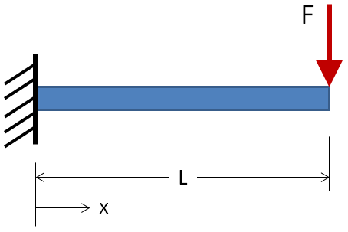
Figure 1: A simple 2-D cantilever.

Beware that the proceedings will be printed in black and white. Make sure that the interpretation of graphs does not depend on colour. In the text, tables and figures should be referred to as Figure 1 and Table 1.

Table 1: Minimum values of spacing and edge and end distances

Title 1 | Title 2 | Title 3
Label | Text / Numeric | Text / Numeric
Label | Text / Numeric | Text / Numeric
Label | Text / Numeric | Text / Numeric
Label | Text / Numeric | Text / Numeric
Label | Text / Numeric | Text / Numeric
Label | Text / Numeric | Text / Numeric
Label | Text / Numeric | Text / Numeric
Label | Text / Numeric | Text / Numeric

The International System of Units (SI) is to be used; other units can be used only after SI indications, and should be added in parenthesis.
Equations should be typed and all symbols should be explained within the manuscript. An equation should be proceeded and followed by one blank line, and should be referred to, in the text, in the form Equation (1).

(1)

Last point: the references. In the text, the references should be a number within square brackets, e.g. [3], or [4]–[6] or [2, 3]. The references should be listed in numerical order at the end of the paper.
Journal references should include all the surnames of authors and their initials, year of publication in parenthesis, full paper title within quotes, full or abbreviated title of the journal, volume number, issue number and pages. Examples below show the format for references including books and proceedings.

References

- M. K. Ghosh and A. Nagraj, “Turbulence flow in bearings,” Proceedings of the Institution of Mechanical Engineers 218 (1), 61 - 64 (2004).
- H. Coelho and L. M. Pereira, “Automated reasoning in geometry theorem proving with Prolog,” J. Automated Reasoning 2 (3), 329-390 (1986).
- P. N. Rao, Manufacturing Technology Foundry, Forming and Welding, 2nd ed. (McGraw Hill, Singapore, 2000), pp. 53 – 68.
- Hutchinson, F. David and M. Ahmed, U.S. Patent No. 6,912,127 (28 June 2005).

